DEPARTMENT OF COMMERCE
FINANCIAL SUPPORT TO POOR STUDENTS: 27.3.2022

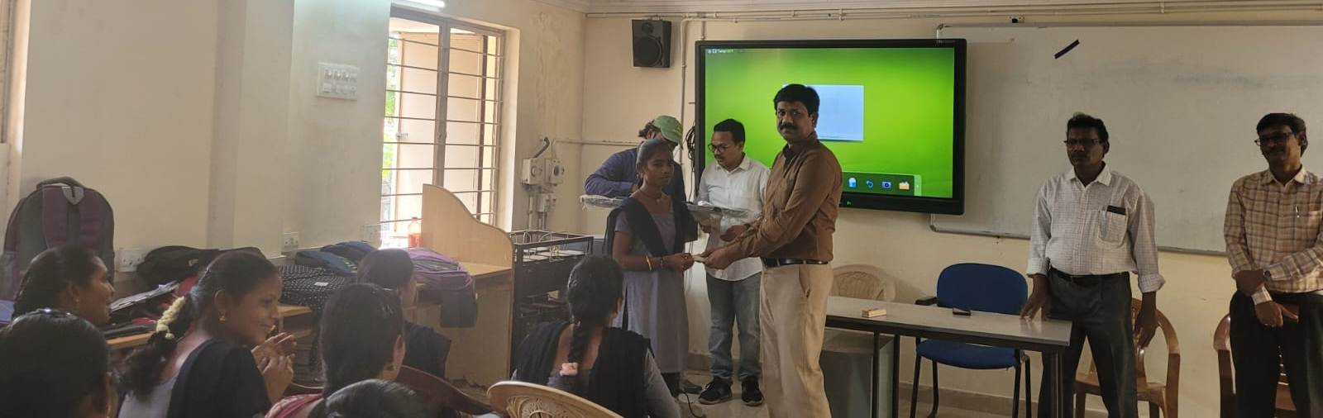

DEPARTMENT OF COMMERCE
FINANCIAL SUPPORT TO POOR STUDENTS: 27.3.2022

DEPARTMENT OF COMMERCE
FINANCIAL SUPPORT TO POOR STUDENTS: 27.3.2022
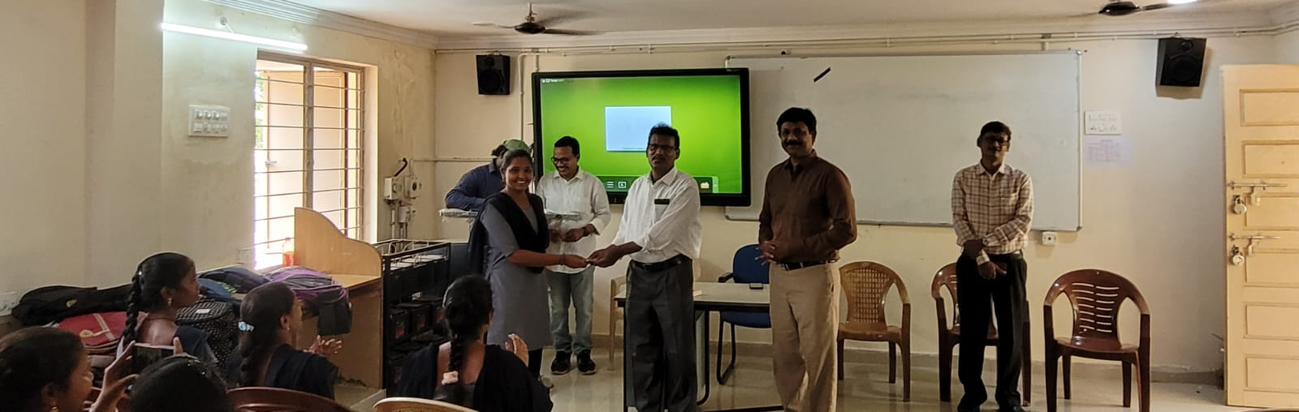

DEPARTMENT OF COMMERCE
FINANCIAL SUPPORT TO POOR STUDENTS: 27.3.2022
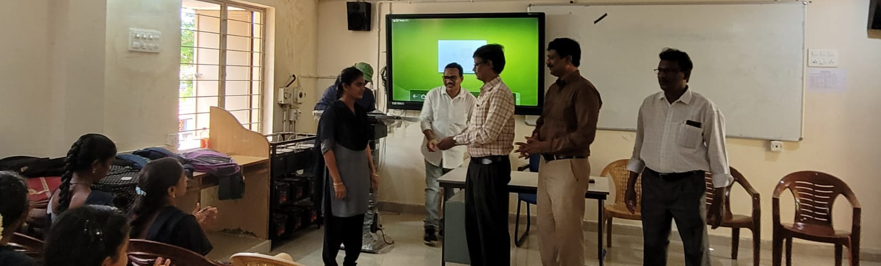
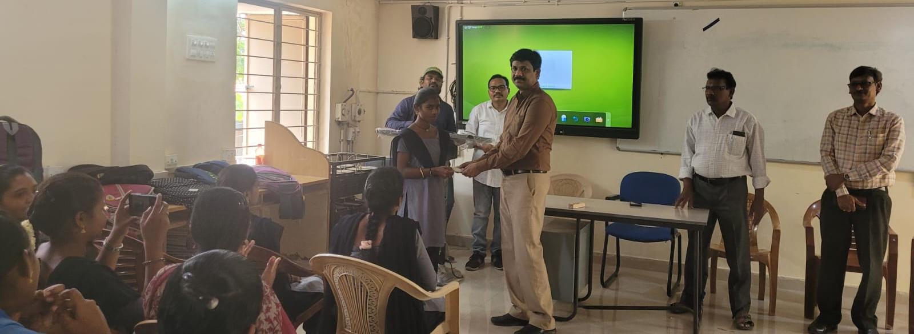

DEPARTMENT OF COMMERCE
FINANCIAL SUPPORT TO POOR STUDENTS: 07.7.22

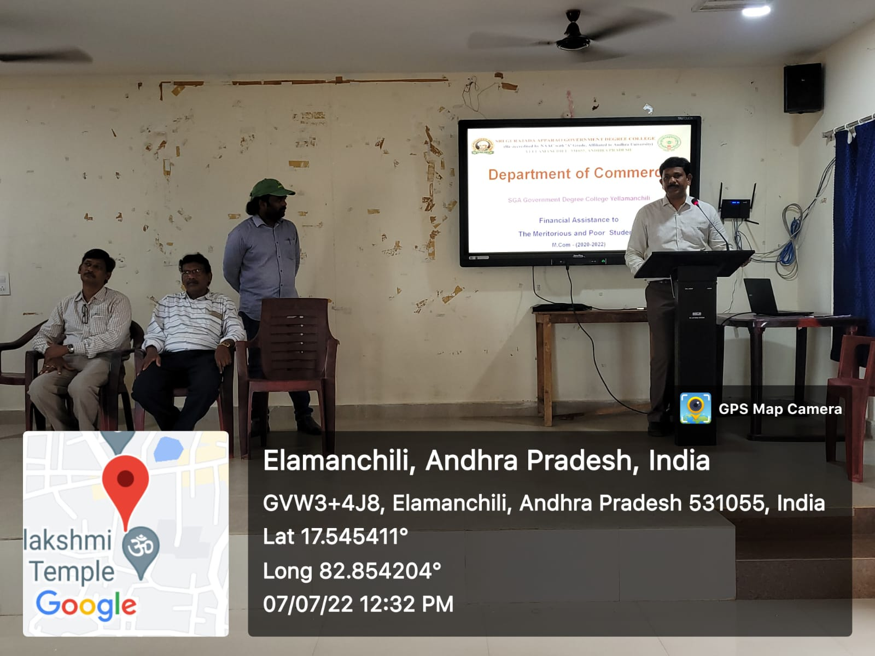

DEPARTMENT OF COMMERCE
FINANCIAL SUPPORT TO POOR STUDENTS: 07.7.22

